DENVER DTS
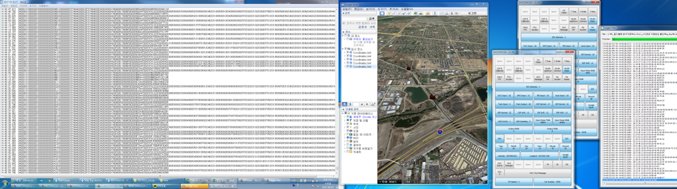
Communication system failure review report
Document Date – 8th June, 2017

Log File analysis procedure
The three types of log files are currently recorded on the Denver communication system and each log file has its own content and usage.

- EMP : File to record GPS reception data.
- SERIAL : The communication data between COMM sub-units and RS485 communication data.
- MAINDLG : CRA-CNCS APP operating event.

When the failure history and MDS failure data are received from the ROTEM / DTS, Woojin collects the log file from the relevant train and starts to analyze the part corresponding to the failure time using Log Analysis Program by Woojin.

Request by Woojin (ROTEM /DTS) :
-> failure history and MDS failure data.
-> When sending the failure history by E-Mail, please refer it to on-site Woojin staff (rthao@wjisamerica.com)

